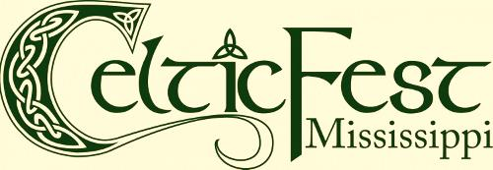

Levels of Sponsorship

Presenting Plus $20,000 +
- All acknowledgements afforded “Presenting Sponsor” plus prominent inclusion in television, radio advertising.

Presenting $15,000
- Prominent company logo placement:
  - Festival t-shirt
  - Festival poster/flier
  - Festival printed program
  - Newspaper advertising
  - CelticFest web site (with link to company web site)
- Company name listing:
  - On-stage mention by festival emcees
  - Press releases
- Stage sponsorship of larger stage
- Opportunity to post company banner at sponsored stage
- Allocation of booth space in vendor area (up to 20’x20’)
- 20 CelticFest t-shirts
- 20 Weekend gate passes

Platinum $10,000
- Prominent company logo placement:
  - Festival t-shirt
  - Festival printed program
  - CelticFest web site (with link to company web site)
- Company name listing:
  - Festival poster/flier
  - Newspaper advertising
  - On-stage mention by festival emcees
  - Press releases
- Stage sponsorship of larger stage
- Opportunity to post company banner at sponsored stage
- Allocation of booth space in vendor area (up to 10’x10’)
- 15 CelticFest t-shirts
- 15 Weekend gate passes

Gold $5,000
- Prominent company logo placement:
  - Festival printed program
  - CelticFest web site (with link to company web site)
- Company name listing:
  - Festival poster/flier
  - Newspaper advertising
  - On-stage mention by festival emcees
  - Press releases
- Stage sponsorship of smaller stage
- Opportunity to post company banner at sponsored stage
- Allocation of booth space in vendor area (up to 10’x10’)
- 10 CelticFest t-shirts
- 10 Weekend gate passes

Silver $1000
- Company logo placement:
  - Festival printed program
  - CelticFest web site (with link to company web site)
- Company name listing:
  - Festival poster/flier
  - Press releases
- Stage sponsorship of workshop or special festival event
- Opportunity to post company banner at sponsored stage/event
- Allocation of booth space in vendor area (up to 10’x10’)
- 2 CelticFest t-shirts

Bronze $500
- Company logo placement:
  - CelticFest web site (with link to company web site)
- Company name listing:
  - Festival printed program
  - Festival poster/flier
- Sponsorship of special festival event (as available)
- Opportunity to post company banner at sponsored event or on festival grounds

Emerald $250
- Company logo placement:
  - CelticFest web site (with link to company web site)
- Company name listing:
  - Festival printed program
- Opportunity to post company banner on festival grounds

Friend up to $250
- Company logo placement:
  - CelticFest web site (with link to company web site)

