A Community Event
CelticFest Mississippi is a family friendly public festival relying on donations of time and talent from its performers, directors, staff, and volunteers. CelticFest has garnered a reputation as a ‘musicians’ festival’, a favorite among its performers, and an increasingly rare gem featuring traditional Celtic music. Headed into its 26th year, the festival will be held once again in the spring after many years as a September event. The feedback we have received from this announced date change has been overwhelmingly positive. Recent census research has indicated that over 375,000 Mississippians claim Irish and Scottish heritage.

Dates Hours
Friday March 23, 2018 6pm – 11pm
Saturday March 24, 2018 10am to Midnight

Location
CelticFest will continue to be held on the grounds of the idyllic Mississippi Agriculture & Forestry Museum. Centrally located off of Interstate 55 and Lakeland Drive in Jackson, MS, the Museum remains open until during the daytime hours, enabling Festival Goers the added benefit of exploring the many buildings and exhibits. The Ag Museum is the perfect location for a family festival.

Attractions
- Four stages of entertainment including traditional Celtic Dance groups and world class musicians, free workshop areas, The Marketplace with Celtic wares, food vendors (including Irish fare), and more.
- The ever popular Saturday night Céilí Mór (Kay-lee More) is the largest céilí (traditional Irish social dancing with live music) in the South.
- Scottish Highland Games Field hosts demonstrations.

Achievements
- Named a Top 20 Event in 2006 and 2010 by the Southeast Tourism Society.
- Celtic Heritage Weekend declared by Governor Barbour in 2008 through 2012.
- Set a world record on number of people (167) performing the Brush Dance in 2010, beating the record set earlier in the year in Clonakilty, Co. Cork, Ireland.
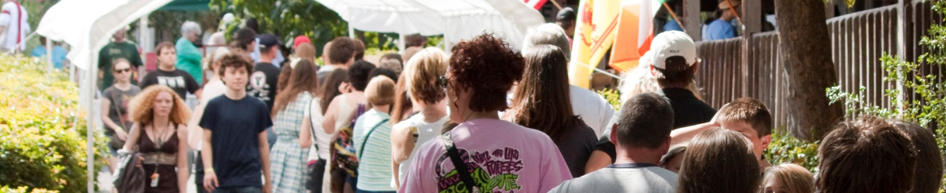

Exposure
Promotions for CelticFest Mississippi result in thousands of media impressions within the state. The festival has an annual attendance in the thousands. We use Social Media year round, as well as our website and email lists to keep our audience updated and engaged. We use press releases and paid advertising to reach all over the State as well as into neighboring Louisiana, Alabama and Tennessee.
Our Guests
CelticFest Attendees come from all age groups, backgrounds, and ethnicities. Most are local to central Mississippi, but the festival draws from all over the state and from neighboring states.
Why Sponsor CelticFest Mississippi?
Experiential marketing through sponsorship of CelticFest Mississippi is a unique and targeted way to get your message in front of thousands of Central Mississippi consumers. Seventy percent of consumers say they would be more likely to purchase a brand after experiencing it at an event. CelticFest is recognized as one of Mississippi’s top events and a cherished cultural institution.

Potential Benefits
Brand awareness On-site space to market products/services or conduct promotions
Database building Recognition in event marketing materials
Hospitality Shared marketing opportunities with other sponsors
Networking Potential for category exclusivity
Naming rights Community involvement and investiture

Consider a CelticFest Mississippi sponsorship opportunity today. To obtain more information on how we can tailor a sponsorship package to help you reach your goals, please contact Suezen Brown, Celtic Heritage Society President, at celticfestms@gmail.com or 601-260-1429.

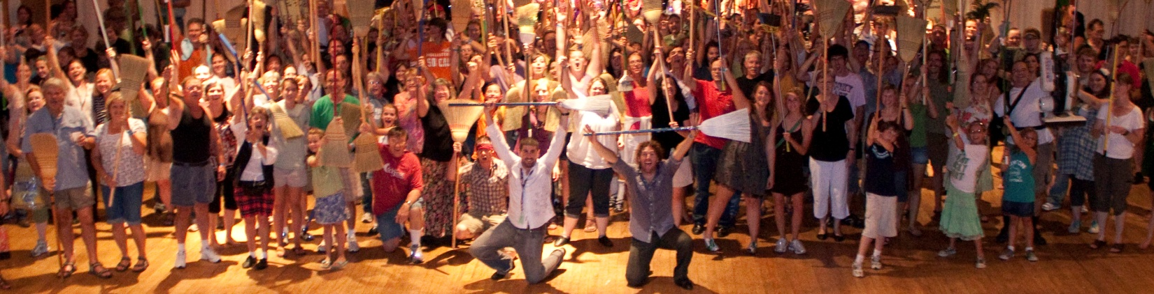

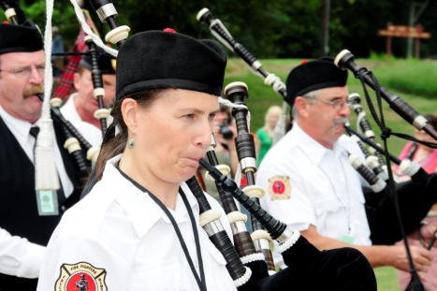
About the Organization
The Celtic Heritage Society (CHS) was founded in Jackson, Mississippi in May 1992, as a 501(c)3 federally tax exempt civic and educational nonprofit organization. Our mission is to study, promote, and preserve Celtic traditions and culture. This includes music, dance, history, language, literature, art and other activities native to Ireland, Scotland, Wales, Brittany, Cornwall, and the Isle of Man.

The CHS was founded by Celtic music and dance enthusiasts who wished to share their enthusiasm for these traditional arts. That spirit of community and volunteerism began at the organization’s founding and continues to this day: the Celtic Heritage Society has no paid Board, staff, festival directors, or committees. The organization is run 100% by volunteers who share the enthusiasm for the music, dancing, and CelticFest Mississippi.

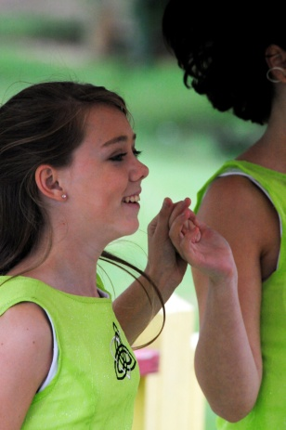
By its charter, membership in the CHS and participation in society functions are open to all. Immigrants from Celtic nations contributed much of their own heritage to the ‘melting pot’ of Southern culture. We encourage participation of all in all CHS activities regardless of one’s personal ethnic background.

CelticFest Mississippi, now in its 26th year, serves as an important vehicle for meeting the society's mission of studying and promoting the musical, artistic, and cultural traditions of the Celtic nations. CelticFest has become ‘the little festival that could’, having grown into one of the defining cultural festivals in Jackson and the state of Mississippi.

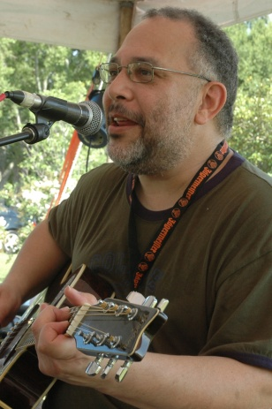
CelticFest Mississippi has included performances from many well-known Celtic musicians and artisans over the years. It has featured workshops on dance, musical instruments, Gaelic language, genealogy, history, literature, Irish culture, and Celtic art; public dances, singing and music sessions; an educational children's area; numerous Celtic exhibits; and ample vending of food and Celtic specialty items. CelticFest has brought internationally and regionally acclaimed artists to Mississippi, including Eileen Ivers, Téada, Paddy Keenan (with John Walsh & Patsy O’Brien), Trían, Liz Carroll & John Doyle, Máirtín de Cógáin, Robbie O’Connell, Randal Bays & Dáithí Sproule, The Fuchsia Band, Brian Conway, Tim Britton, Jimmy Crowley, Captain Mackey’s Goatskin & String Band, Bua, Brian McNeill, Brían Ó hAirt, Donie Carroll with Don Meade & Dan Neely, John Williams & Dean Magraw, and Brendan Nolan.

In addition to the festival, the CHS sponsors céilís throughout the year (pronounced "kay-lee"--a Celtic celebration featuring traditional music and dance), as well as music events, fun and informative workshops, and meetings on topics such as Irish dance, Gaelic language, etc. CHS functions are intentionally family events--children are always welcome.

